The Psychopath Next Door

The media tend to portray psychopaths as violent, intelligent, successful and either charismatic or withdrawn. OR, completely insane, by which I mean they have lost the ability to distinguish reality from fantasy and are suffering from psychosis.

Most of us think of the psychopath as a serial killer — a monster like Colonel Russell Williams, Paul Bernardo or Clifford Olsen. But most psychopaths are not physically violent criminals. They live among us, undetected. Experts believe between one and two per cent of the general adult male population are psychopaths, which means there could be 300,000 of them in Canada alone. The ‘successful’ psychopath could be your neighbour, your boss, your spouse, or your friend.
“Psychopaths are every bit as rational as any human being, if not more so, because they don’t have the noise of human emotion,’’ says Dr. Stephen Porter, Professor of Forensic Psychology at the University of British Columbia. “Psychopaths do know right from wrong in the 'cognitive' or rational sense, and even do as well on moral-reasoning tasks in the lab setting as the rest of us.” Many psychopaths are highly skilled at mimicking normal human emotion, using charisma, manipulation and intimidation to satisfy their own needs. No wonder the psychopath is so hard to detect.
Dr. Robert Hare, professor emeritus at UBC and the FBI's top consulting psychologist on psychopaths, devised the Psychopathy Checklist, used by psychologists around the world to determine the degree of psychopathy in subjects. “They want many of the same basic things that the rest of us but in addition have an inordinate need for power, prestige, wealth, and so forth,” says Hare. “They differ from most of us in terms of how much they 'need', their sense of entitlement to whatever they want, and the means with which they are willing to achieve their ends."
Ironically, the ruthless winner-take-all ethos of North American culture nurtures and rewards psychopathy. Charming, manipulative and ruthless, these are the “snakes in suits” who don’t rob the bank, but instead become a director of it. These “successful psychopaths” — those who attain prominent positions in society — may be overrepresented in certain occupations, such as politics, entertainment and business.
Psychopaths love chaos and hate rules, so they tend to thrive in the fast-moving world of business, says Dr. Paul Babiak, a psychologist from New York City. "They have traits similar to ideal leaders. You would expect an ideal leader to be narcissistic, self-centred, dominant, very assertive, maybe to the point of being aggressive." They are verbally abusive, subject to rages and totally lacking in empathy or remorse, all of which makes them natural predators.
The Psychopath Next Door provides a chilling and provocative examination of those in our midst who act without conscience. And we’ll hear from those whose hope is to one day discover a treatment for the psychopath — a term coined in the 1880s whose literal meaning is “suffering soul”.

What is the difference between Sociopath and Psychopath?
While both terms are used interchangeably, there does seem to be difference.
However, current trends suggest that the terms ‘sociopath’ and ‘psychopaths’ reflect differing characteristics of Personality Disorders, rather than two distinct and separate diagnoses.

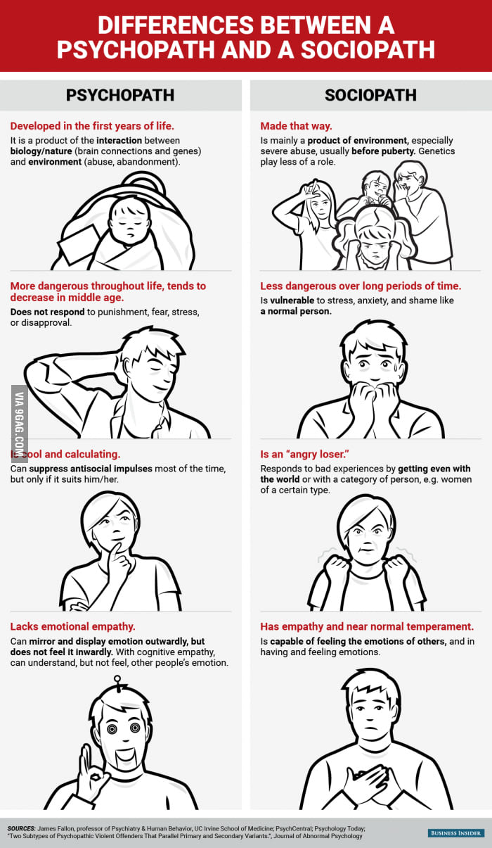

Document 1

The official stance of the American Psychiatric Association as presented in the DSM-IV-TR is that psychopathy and sociopathy are misnomers. The World Health Organization takes a different stance in its ICD10 by referring to psychopathy, antisocial personality, asocial personality, and amoral personality as synonyms for dissocial personality disorder.
Among laypersons and professionals, there is much confusion about the meanings and differences between psychopathy, sociopathy, antisocial personality disorder, and the ICD-10 diagnosis, dissocial personality disorder. Hare takes the stance that psychopathy as a syndrome should be considered distinct from the DSM-IV's antisocial personality disorder construct, even though ASPD and psychopathy were intended to be equivalent in the DSM-IV. However, those who created the DSM-IV felt that there was too much room for subjectivity on the part of clinicians when identifying things like remorse and guilt; therefore, the DSM-IV panel decided to stick to observable behavior, namely socially deviant behaviors.
As a result, the diagnosis of ASPD is something that the "majority of criminals easily meet." Hare goes further to say that the percentage of incarcerated criminals that meet the requirements of ASPD is somewhere between 80 to 85 percent, whereas only about 20% of these criminals would qualify for a diagnosis of what Hare's scale considers to be a psychopath. This twenty percent, according to Hare, accounts for 50 percent of all the most serious crimes committed, including half of all serial and repeat rapists. According to FBI reports, 44 percent of all police officer murders in 1992 were committed by psychopaths.

Source: http://www.minddisorders.com/knowledge/Hare_Psychopathy_Checklist.html#ixzz2Ng8ZmfpH
On a separate piece of paper, answer these following questions based on Document 1:

- According to the American Psychiatric Association (APA), why do they only use the term Antisocial Personality Disorder rather than Psychopath or Sociopath?

- What percentage of criminals in prison are considered to have Antisocial Personality Disorder (ASPD) versus Psychopathy?

- Why do you believe that most cop killers are Psychopaths?

Document 2

Psychopathy is a term that was created by Hervey Cleckley in 1941. This word was initially used to discuss individuals that possessed artificial charisma and intellect, and that were non-empathetic, deceitful in nature, careless, incapable of guilt or real concern for people, and fearless (Larsen & Buss, 2010). Psychopaths feel no compassion for other humans, which is why they frequently abuse (emotionally and/or physically), murder, manipulate, deceive, con, and abandon other people. They are able to do this because they are often masterful manipulators and actors, often times being able to keep up the appearance of being completely normal. Many of them are observant, charming, human chameleons that can easily blend in with their social environment (Hare, 1993). From an evolutionary standpoint, this makes plenty of sense. Humans that blatantly show zero concern for fellow humans, through such actions as murder and abandonment, are going to stick out in a negative manner. Of course, not all psychopaths avoid behaving in violent or conning ways that can get them put into prison. Certain serial killers that are currently incarcerated or were incarcerated prior to their death are prime examples of this. Prison is where many people assume that most psychopaths are located, but this is an inaccurate and dangerous belie (Hare, 1993).
The incarcerated psychopaths, however, are what a great deal of the available research on psychopathy has been conducted on. It can be very difficult to successfully identify psychopaths, even the ones that are in prison for violent crimes. This is so because the majority of them are exquisite liars, and a lot of them are smart enough to know what researchers are looking for on psychological tests and in one-on-one interviews. In fact, there are inmates that obtain books dealing with psychological testing and various other areas in the field of psychology. These inmates study the material and then, in return for payment, instruct fellow inmates how to answer psychological tests in a manner that will make them look good and possibly get them an early release from jail (Hare, 1993). So, this means that psychopaths can learn how to efficiently trick psychometric tests while they are in prison. Psychopaths have much better access to information about psychological testing and psychology in general when they are not imprisoned, obviously including research regarding psychopathy. It is possible that some of them receive actual training or college degrees in psychology, making them that much more adept at avoiding detection. In summary, it is not as simple to correctly recognize a psychopath as the media and Hollywood make it appear to be. Someone is not automatically a psychopath because they committed murder, rape, torture, etc. There are certain personality traits and socially undesirable behaviors that must be present before someone can be diagnosed as a psychopath (Hare, 1993).
- Why are Psychopaths able to manipulate people so easily?
- Why are Psychopaths so difficult to diagnose? (Answer in more detail than just stating that they are liars.)

Document 3a

In practice, mental health professionals rarely treat psychopathic personality disorders as they are considered untreatable and no interventions have proved to be effective. In England and Wales the diagnosis of dissocial personality disorder is grounds for detention in secure psychiatric hospitals under the Mental Health Act if they have committed serious crimes, but since such individuals are disruptive for other patients and not responsive to treatment this alternative to prison is not often used. Because an individual's scores [from the Psychopath Test] may have important consequences for his or her future, the potential for harm if the test is used or administered incorrectly is considerable. The test can only be considered valid if administered by a suitably qualified and experienced clinician under controlled conditions.

- After looking at Documents 3a and 3b, in your opinion, why do you think that psychopathic personality disorder is considered untreatable?
- Why shouldn’t anyone just take the psychopath test on their own?

Document 3b

PCL-R model of psychopathy (AKA The Psychopath Checklist)
The PCL-R is a clinical rating scale (rated by a psychologist or other professional) of 20 items. Each of the items in the PCLR is scored on a three-point scale according to specific criteria through file information and a semi-structured interview.
Factor 2: Case history
"Socially deviant lifestyle".
• Need for stimulation/proneness to boredom
• Parasitic lifestyle
• Poor behavioral control
• Lack of realistic long-term goals
• Impulsivity
• Irresponsibility
• Juvenile delinquency
• Early behavior problems
• Revocation of conditional release

Factor 1: Personality "Aggressive narcissism"

• Glibness/superficial charm
• Grandiose sense of self-worth
• Pathological lying
• Cunning/manipulative
• Lack of remorse or guilt
• Shallow affect (genuine emotion is short-lived and egocentric)
• Callousness; lack of empathy
• Failure to accept responsibility for own actions

Traits not correlated with either Factor:
Promiscuous sexual behavior
Many short-term marital relationships
Criminal versatility
Acquired behavioural sociopathy/sociological conditioning

Document 4

Watch the following clip:
ANTISOCIAL PERSONALITY DISORDER (Joker Character Analysis: Dark Knight)

http://www.youtube.com/watch?v=TCBSU7CsYcc (5:18)

Be specific in answering these questions. Use your own ideas and observations based on the readings and video clips

A. How can “nature” lead to psychopathy?

B. Name 5 symptoms of psychopathy.

Document 5: Causes of Psychopathy?

Genetics
In regards to genetic causes, one belief is that there is an inherited abnormality that causes unhealthy and abnormal emotional thinking. What this denotes is that it is not that psychopaths inherit bad behaviors, but that their acquired genes cause them to develop unnatural emotional processing, as compared to the emotional processing in the brains of normal people. The development of anomalous emotional processing in the brains of psychopaths is responsible for their antisocial behaviors and non-human-like cognitions (Blair, Mitchell, & Blair, 2005). This would explain why psychopaths do not have the cognitive abilities to accurately interpret, recognize, and feel typical human emotions. This unusual brain functioning prevents them from being able to empathize and care about other people's feelings. A psychopath may be able to recognize what certain facial expressions represent (e.g., pain, sadness, anger), but they cannot put themselves in the other person's shoes in order to determine what someone is feeling underneath a particular countenance. And since psychopaths primarily and often only worry about themselves, it is unlikely that they would even bother to take the time to try and figure out what someone else is feeling.

Socialization
The social upbringing is another area of focus for the causality of psychopathy. One causal theory is that psychopaths grow up in environments where their aggression and cruelty go unpunished and possibly even get reinforced by others. Parents may reinforce their child's aggressive and violent behavior by giving in to what the child wants. For example, a kid may start threatening to punch or actually punching a sibling as a means to receive some type of desired object/event (e.g., candy). If the parents give in to their child's demand(s), the violence/aggression is rewarded and the child learns that violence and aggressiveness are acceptable methods to get what they desire; the negative behavior is more likely to happen again in the future. This can easily lead to socially deviant and destructive actions, and may also prompt a person meeting the qualifications for other psychological disorders, such as conduct disorder or antisocial personality disorder (Hare, 1993).
Source: http://abnormalpsych.wikispaces.com/psychopathy

A. How can nature play a role in the development of psychopathy?

B. How can nurture play a role in the development of psychopathy?

Document 6
A serial killer is traditionally defined as an individual who has killed three or more people over a period of more than a month, with down time (a "cooling off period") between the murders, and whose motivation for killing is usually based on psychological gratification. Some sources, such as the FBI, disregard the "three or more" criteria and define the term as "a series of two or more murders, committed as separate events, usually, but not always, by one offender acting alone" or, including the vital characteristics, a minimum of two murders. Often, a sexual element is involved in the killings, but the FBI states that motives for serial murder include "anger, thrill, financial gain, and attention seeking". The murders may have been attempted or completed in a similar fashion and the victims may have had something in common; for example, occupation, race, appearance, sex, or age group.
Source: http://en.wikipedia.org/wiki/Serial_killer

A. Define serial killer (according to your understanding in your own words)
B. According to the FBI, what are common motives for serial murder?

Document 7
Watch the following video:
http://www.youtube.com/ watch?v=D30mjWsC8C4&l ist=PL9214E23B4F4918F0 (2:01)
This clip is from the movie “Seven” where “John Doe” killed 7 people who he believed exhibited the seven deadly sins.
A. Is John Doe a Serial Killer? Why?
B. Is John Doe a psychopath? Why?

Document 8
Because they don't become attached to their victims, serial killers are able to perform experiments on those they've killed
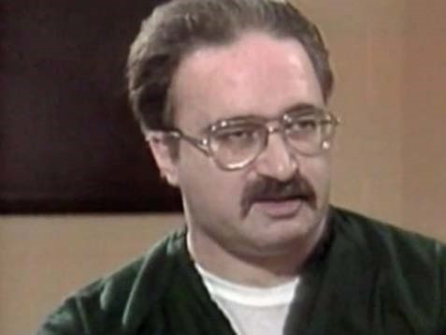
Robert Berdella, the so-called Kansas City Butcher, raped, tortured and killed at least six men between 1984 and 1987. He experimented on his victims and kept scientific notebooks, Morrison said. As part of his experiments, he poured Drano down victims' throats so they couldn't scream.
"I think its just like pulling the wings off a fly when you're a kid," Morrison said. "Just that 'let's see what happens.'"
Notorious serial killer John Wayne Gacy also experimented on victims but showed absolutely no emotion, Morrison said.
"The complete lack of humanity is more than just being a psychopath because at least the psychopath has the capacity to express emotion," Morrison said.
Source: http://www.businessinsider.com/12-shocking-and-twisted-facts-about-the-worlds-serial-killers-2012-6?op=1#ixzz2NdJq8M44

- After reading this document, why do you believe that psychologists have found that many serial killers have higher than average IQ’s?
- Do you agree with Morrison, are these examples of serial killers “worse” than regular psychopaths?

Document 9

The shocking thing is many of these men have partners who are clueless.
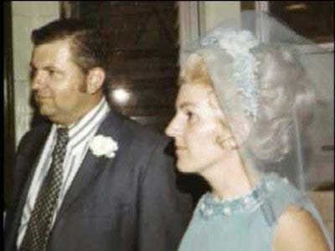
In the course of her research, Morrison had the opportunity to interview serial killers' wives as well. And from what she could gather, none of these women consciously knew what was going on. Or, they never questioned it.

John Wayne Gacy buried his victims under his house. But when Morrison asked Carol Hoff, Gacy's wife, if she smelled anything, Carol said John said the smell was because of mice. And Carol completely accepted his explanation.
"Wrap your head around that one," Morrison said.

But don't expect the women to take part in the crimes, at least most of the time.

"No it’s not an equal opportunity kind of thing," Morrison said.

Serial killers are almost always men. Women may become a companion to the serial killer, but they aren't the ones initiating the crimes. And women companions taking part in the crimes is very rare, she said.

Serial killers' partners are often nearly-incomplete people whom the serial killers can bring into themselves. "Whatever is missing in that woman is fulfilled by part of the serial killer," Morrison said. These women take passivity to an extreme, and often exhibit a complete lack of assertiveness.

However, the research on serial killers' partners is limited because often these women feel they can't talk unless given permission by the serial killer.

Source: http://www.businessinsider.com/12-shocking-and-twisted-facts-about-the-worlds-serial-killers-2012-6?op=1#ixzz2Ng6Ud16o

- Why might serial killers be able to easily hide their true identities from their mates?
- Why might women who have low self-esteem be attracted to the personalities of serial killers?

Document 10
Watch the following clip:
http://www.youtube.com/ watch?v=G4qblq0uahw&li st=PL9214E23B4F4918F0
(1:47)

A. What is Hannibal doing to manipulate Clarisse? Be specific.

B. Why did Hannibal mention what happened to the Census worker? What was he hoping to gain?

